

oneM2M
Technical Report
Document Number | TR-0040-V0.0.2
Document Name: | Trust Management in oneM2M
Date: | 2018-January-18
Abstract: | This technical report identifies and documents issues related to the establishment of trust in oneM2M platform inter-domain use cases. It will investigate and document the definition of trust in IoT system, and recommend a trust establishment model. The report will evaluate how trust evaluation can be carried out, starting with scenarios in the smart-city context, and identify the trust properties required of IoT entities across oneM2M platform domains. Where identity and identifiers are used in determing trust, this work item will evaluate the means of assigning trust to such elements that allow for identity evaluation and ensuring enforcement of policy over the IoT data.
Template Version: 08 September 2015 (Do not modify)

This Specification is provided for future development work within oneM2M only. The Partners accept no liability for any use of this Specification.
The present document has not been subject to any approval process by the oneM2M Partners Type 1. Published oneM2M specifications and reports for implementation should be obtained via the oneM2M Partners' Publications Offices.

About oneM2M
The purpose and goal of oneM2M is to develop technical specifications which address the need for a common M2M Service Layer that can be readily embedded within various hardware and software, and relied upon to connect the myriad of devices in the field with M2M application servers worldwide.
More information about oneM2M may be found at: http//www.oneM2M.org
Copyright Notification
© 2016, oneM2M Partners Type 1 (ARIB, ATIS, CCSA, ETSI, TIA, TSDSI, TTA, TTC).
All rights reserved.
The copyright and the foregoing restriction extend to reproduction in all media.

Notice of Disclaimer & Limitation of Liability
The information provided in this document is directed solely to professionals who have the appropriate degree of experience to understand and interpret its contents in accordance with generally accepted engineering or other professional standards and applicable regulations. No recommendation as to products or vendors is made or should be implied.
NO REPRESENTATION OR WARRANTY IS MADE THAT THE INFORMATION IS TECHNICALLY ACCURATE OR SUFFICIENT OR CONFORMS TO ANY STATUTE, GOVERNMENTAL RULE OR REGULATION, AND FURTHER, NO REPRESENTATION OR WARRANTY IS MADE OF MERCHANTABILITY OR FITNESS FOR ANY PARTICULAR PURPOSE OR AGAINST INFRINGEMENT OF INTELLECTUAL PROPERTY RIGHTS. NO oneM2M PARTNER TYPE 1 SHALL BE LIABLE, BEYOND THE AMOUNT OF ANY SUM RECEIVED IN PAYMENT BY THAT PARTNER FOR THIS DOCUMENT, WITH RESPECT TO ANY CLAIM, AND IN NO EVENT SHALL oneM2M BE LIABLE FOR LOST PROFITS OR OTHER INCIDENTAL OR CONSEQUENTIAL DAMAGES. oneM2M EXPRESSLY ADVISES ANY AND ALL USE OF OR RELIANCE UPON THIS INFORMATION PROVIDED IN THIS DOCUMENT IS AT THE RISK OF THE USER.

Contents
Contents 3
1 Scope 4
2 References 4
2.1 Normative references 4
2.2 Informative references 4
3 Definitions, symbols and abbreviations 4
3.1 Definitions 4
3.2 Symbols 5
3.3 Abbreviations 5
4 Conventions, 5
5 Trust in oneM2M 5
5.1 Introduction to IoT trust 5
5.2 Neccessity of TRUST in oneM2M 6
6 oneM2M Trust Establishment 6
6.1 User defined subdivisions of clause(s) from here onwards 6
7 oneM2M Trust Use Cases 7
8 Trust Properties in oneM2M 8
9 Conclusion and Recommendations 8
Proforma copyright release text block 8
Annexes 8
Annex <y>: Bibliography 9
History 9

1 Scope
The present document …
EXAMPLE: The present document provides the necessary adaptions to the endorsed document.
The Scope shall not contain requirements.

2 References

2.1 Normative references
As a Technical Report (TR) is entirely informative it shall not list normative references.
The following referenced documents are necessary for the application of the present document.
Not applicable.

2.2 Informative references
The following referenced documents are not necessary for the application of the present document but they assist the user with regard to a particular subject area.
[i.1] oneM2M Drafting Rules (http://www.onem2m.org/images/files/oneM2M-Drafting-Rules.pdf)
[i.2] ITU-T SG16 CG Trust TR “Trust Provisioning in future ICT infrastructure”
[i.3] ITU-T SG16/13 Draft recommendation Y.trust-provision
[i.4] ETSI ISG NFV-SEC-003 v1.1.1.(2014-12) “ NFV Security; Security and Trust guidance”
[i.5] oneM2M security brief “ Security solutions and services for the IoT”

3 Definitions, symbols and abbreviations
Delete from the above heading the word(s) which is/are not applicable.

3.1 Definitions
Clause numbering depends on applicability.
- A definition shall not take the form of, or contain, a requirement.
- The form of a definition shall be such that it can replace the term in context. Additional information shall be given only in the form of examples or notes (see below).
- The terms and definitions shall be presented in alphabetical order.
For the purposes of the present document, the [following] terms and definitions [given in ... and the following] apply:
Definition format
<defined term>: <definition>
If a definition is taken from an external source, use the format below where [N] identifies the external document which must be listed in Section 2 References.
<defined term>[N]: <definition>
example 1: text used to clarify abstract rules by applying them literally
NOTE: This may contain additional information.

3.2 Symbols
Clause numbering depends on applicability.
For the purposes of the present document, the [following] symbols [given in ... and the following] apply:
Symbol format
<symbol> <Explanation>
<2nd symbol> <2nd Explanation>
<3rd symbol> <3rd Explanation>

3.3 Abbreviations
Abbreviations should be ordered alphabetically.
Clause numbering depends on applicability.
For the purposes of the present document, the [following] abbreviations [given in ... and the following] apply:
Abbreviation format
ARIB Association of Radio Industries and Businesses
ATIS Alliance for Telecommunications Industry Solutions
CCSA China Communications Standards Association
ETSI European Telecommunications Standards Institute
TIA Telecommunications Industry Association,
TSDSI Telecommunications Standards Development Society
TTA Telecommunications Technology Association
TTC Telecommunication Technology Committee
<ABBREVIATION1> <Explanation>
<ABBREVIATION2> <Explanation>
<ABBREVIATION3> <Explanation>

4 Conventions,
The key words “Shall”, ”Shall not”, “May”, ”Need not”, “Should”, ”Should not” in this document are to be interpreted as described in the oneM2M Drafting Rules [i.1]

5 Trust in oneM2M

5.1 Introduction to IoT trust
Trust is generally defined as to the confidence in the integrity of an entity for reliance on that entity to fulfil specific responsibility. As the definition contains multiple keywords of the major areas in security and privacy, it often tends to be used as a general conceptual term that outlines those areas entirely. NIST definition of trustworthiness focuses more on the reliable operation of CPS while integrating five properties; security, privacy, safety, reliability, and resiliency. These conceptual approaches provide a room for prejudice that the trust is a resultive response of security related functions, and the abstracted notions may cause a different meaning of trust measurement and validation depending on the specific use cases.
Standardization of trust in IoT system is motivated by the recent progress of IoT- trust technlogy that tackles with the provisioning of trust platform taking computational trust as key property to establish trustworthy connectivity over untrustworthy environment. Emerging solutions of IoT system introduce a large scale of interworking of things with instant association, such as social IoT in smart city environment, which assumes the need of interworking of things across multiple stakeholders where trust may not be guaranteed instantly. Standardised trust platform opens a new opportunity to establish a level of trust relationship in this case, out of the security environment dedicated to each stakeholders and their trusted service domains.
Not only the case is the interworking of things with instant association across the untrustworthy service domains, but also the interworking across the cyber-physical domain does matter in terms of trust. IoT intermediates between physical and cyber worlds to extend connectivity, and consequently to promote the effect that openness in the cyber world fuses to the real world. It has been basically regarded as the innnovation power of IoT system for creating new values, but it confuses the existing infrastructure of value operation in each different world. It expands the opportunity for fraud and abuse based on anonymity to damage the value of the physical world, and also increases the threats of collecting, reprocessing, exposure and abuse of privacy related information. Validation of trustworthiness should be reinforced in case of cyber-physical interworkings, taking the threats across the domains into account.
5.1.1 Models of computational Trust
5.1.2. Trust threats in societal IoT interworking
5.1.3. Trust threats in cyber-physical interworking:
5.1.4. Trust management functions for IoT system

Editor’s note 1: this clause starts with the general definition of trust, motivation of TRUST in IoT system, and the conceptual model of computational trust and trust provisioning in general view point. It will bring the defintions of trust relationship, trust domains, and trust provisioning into the discussion.(added201801) Above mentioned aspect of IoT trust impacts the overall layers of IoT system, so that to add a dual stack of trust inter-domain interworking functions beside IoT protocol stack.

5.2 Neccessity of TRUST in oneM2M
There is an increasing potential of oneM2M to face the societal trust interworking, as oneM2M claims to support resource and data sharing through horizontal integration. The entities in multiple stakeholders implementing different security policies and measures will be fallen into the confusion that their service delivery medium is trustworthy but the service and resourece shared with other stakeholders are not trustworthy. Defining the trust relationship between the entities and domains integrated through oneM2M platform will be getting more indispensable on this aspect of interworkings.
The horizontal integration of oneM2M platform enables m:n relationship of resources & applications in different security environment of different service providers; it give rise to the possibility of (1) inappropriate use/ unauthorized restoration of data, (2) unfaithful or interfered operation of resources, or (3) discrimination enabled by analytics, etc.
IoT system works differenctly with human centered communication systems; it is mandated to work for the given functionality only, and inherently to have no other sense or doubt to undefined signals from the system. IoT systems should be programed to act to any simple symptom of untrustworthiness, as with the supplements of trust management functionality to each layer of IoT system protocols and platforms.
Such supplement of trust management functions in the layers of IoT system varies along with the expansion of integration by oneM2M platform, and also with the rise of knowledge processing layers on the top of the data processing in the platform. The more intelligent and abstracted the information processing in IoT system with the platform, the more it enables the physical integration controlled by cyber controls; it gives more requirements to the trust management function in the IoT platform and protocols.
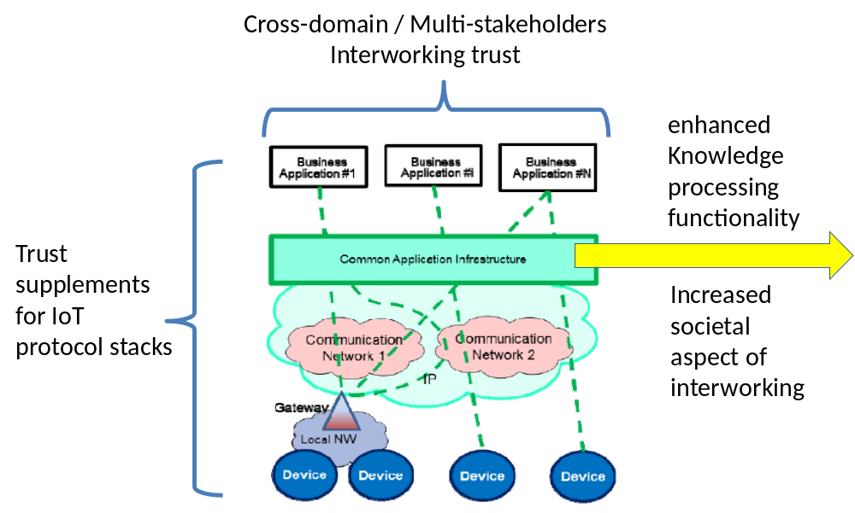

Editor’s note 2: After the definition of such procedures, a characteristics of oneM2M platform is analysed in terms of trustworthiness. Identified that the characteristics of oneM2M is in need of trust establishment to extend its capability to horizontal integration in multiparty administrative environment, to support large scale implementation including CPS systems, and to address potential risks in IoT system under distrusted environment.

6 oneM2M Trust Establishment

6.1 User defined subdivisions of clause(s) from here onwards

Editor’s note 1: Trust is genelly domain – specific property, so the property and architecture follows the domain specific aspect. However, oneM2M is just a general-purpose IoT service platform that is aiming to support various type of systems. It can support small scale M2M operators’ service interworking, device management for IoT device owners, and smart city or large scale operations as well. Area of application is various, and the trust establishment would be variable too. Including all the potential area in light of high level vision of oneM2M trust, the areas of establishing trust model in oneM2M are listed and described as followings:
  - Platform domain trust : (enhanced security & trust of oneM2M)
    - To make sure the oneM2M platform and related domains/entities interworking trustable, to support (existing) operations with (enhanced) trust.
  - IoT trust : (Cyber-Physical-Social System trust)
    - Device trust : device reliability/ availability
    - IoT data trust : OAM&P , data protocol
    - Context-aware IoT trust : context-aware operation, share data analytics to applications
  - Smart city & CPS trust : (Trust for large scale/ time critical integration)
    - Trust for heterogeneous platforms interworking : trust policy negotiation, etc.
    - CPS trust: trust encompassing physical & cyber world. Trust assurance facet or digital object market
Editor’s note 2: The lifecycle management procedues of trust in oneM2M is listed and described at this point. Trust is assigned, evaluating and validating schemes are defined strategically. In some case of disruption on the trust relationship, it should be re-evaluated and re-established. This process is important to prevent from the man-in-the-middle attack. When a trust relationship is to be expired, an invalidating procedure is to be peformed.
Editor’s note 3: This clause should also include an analysis of the relevant security mechanisms existing in oneM2M from a trust perspective.

7 oneM2M Trust Use Cases
Editor’s note: based upon the area of Trust establishment model developed above, use cases corresponding to the areas are examined in this section. This could be formatted as a popular standard style (e.g. intra domain , inter domain..etc.) but in this case more descriptive way is preferred as there are too many similar terminologies flooding in this category. The use cases will be described along wth the following topics:
- Trust establishment for interworking oneM2M nodes under different ownership
- Trust establishment for oneM2M entities interworking with non-oneM2M entities in different ownership domains
- Trust establishment for oneM2M field node for device sharing
- Trust establishment for oneM2M data sharing, context-aware data sharing
- Trust establishment for oneM2M platform working in a smart city, in cooperation with heterogeneous type platforms
- Trust establishment for oneM2M platform working for an industry domain under a critical condition
- Trust establishment for oneM2M platform working for convergence service environment ( heterogeneous CPS system, ownership based trust application, etc.)
- Trust establishment for oneM2M platform with city cloud, public IoT, etc.
<Text>

8 Trust Properties in oneM2M
- Editor’s note 1 : Based upon the results from the research carried through the previous sections, TRUST properties of oneM2M will be broadly deducted:
  - it would be a form of potential meta data of attributes related to the trustworthiness of oneM2M system
  - It will also investigate the trust mechanisms necessary for oneM2M entities
- Editor’s note 2: Research in the identity verification, authentication, and data privacy preservation are FFS.

<Text>

9 Conclusion and Recommendations
Editor’s Note: This clause will capture agreed conclusions and recommendations
<Text>

Proforma copyright release text block
This text box shall immediately follow after the heading of an element (i.e. clause or annex) containing a proforma or template which is intended to be copied by the user. Such an element shall always start on a new page.
Notwithstanding the provisions of the copyright clause related to the text of the present document, oneM2M grants that users of the present document may freely reproduce the <proformatype> proforma in this {clause|annex} so that it can be used for its intended purposes and may further publish the completed <proformatype>.
<PAGE BREAK>

Annexes
Each annex shall start on a new page (insert a page break between annexes A and B, annexes B and C, etc.).
Use the Heading 9 style for the title and the Normal style for the text.
Annex <A>:
Title of annex (style H9)
<Text>
<PAGE BREAK>
Annex <B>:
Title of annex (style H9)
<Text>
B.1 First clause of the annex (style H1)
<Text>
B.1.1 First subdivided clause of the annex (style H2)
<Text>
<PAGE BREAK>

Annex <y>:
Bibliography
The annex entitled "Bibliography" is optional.
It shall contain a list of standards, books, articles, or other sources on a particular subject which are not mentioned in the document itself.
It shall not include references mentioned in the document.
Use the Heading 9 style for the title and B1+ or Normal for the text.
- <Publication>: "<Title>".
OR
<Publication>: "<Title>".
<PAGE BREAK>

History
This clause shall be the last one in the document and list the main phases (all additional information will be removed at the publication stage).
Publication history
V.1.1.1 | <dd Mmm yyyy> | <Milestone>

Draft history (to be removed on publication)
V.0.0.1 | 06 Dec 2016 | Initial skeleton
 | <dd Mmm yyyy> | <CR ID> applied – <Summary of changes>

